Introduction to Student Growth Measures and SLOs
Module 1
Slide 1

Slide 4

Review the intended outcomes of this module.

Slide 5  Review the content of this slide. While this list presents who is usually excluded from OTES, exceptions may exist where one of these professionals is evaluated under OTES provided they hold a teacher’s certificate and spend at least 50 percent of his/her time providing student instruction. | 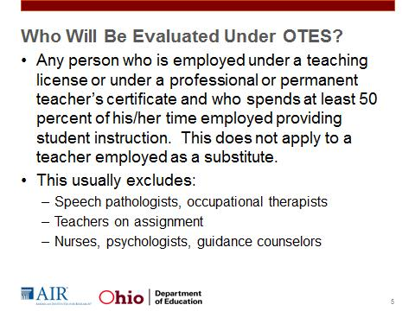
Slide 6  Student growth measures shall account for fifty percent (50%) of the teacher evaluation. | 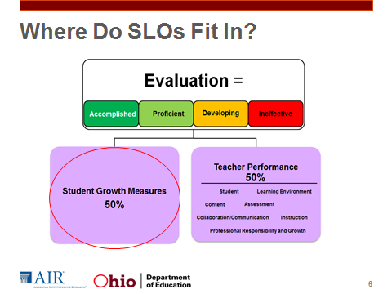
Slide 7  For the purpose of use in the OTES model, student growth is defined as the change in student achievement for an individual student between two or more points in time. In Ohio’s LEAs, the student growth component will be comprised of a combination of two or more measures of value-added scores, vendor-created assessments, and LEA-determined student growth measures. | 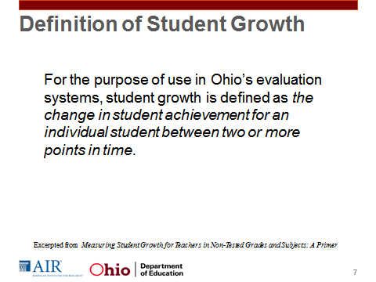
Slide 8  The combination of measures within the OTES model will vary depending on the grades and subjects taught. The guidelines given will be updated as research and best practices emerge to inform revisions. The combination of measures will fall into the following categories:  - Teachers with value-added data  - Teachers in nontested grades and subjects with vendor assessment growth measures  - Teachers in nontested grades and subjects without comparable vendor assessments  This Slide does not reflect the most recent guidance in growth measures. | 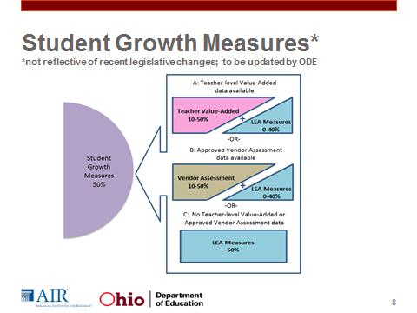
Slide 9  One measure of student growth is value added. Value-added measures use statistical methods to determine a teacher’s impact on his or her students using data from student achievement tests. Teachers who have value-added data must have this information used in their evaluation. We refer to this group of teachers as Category A teachers. Category A includes teachers of reading and mathematics in grades 4-8 in all districts, as well as some science teachers in SOAR districts who receive value-added reports and TIF districts who use EVAAS.”  Note to the trainer: The Ohio legislature recently passed HB 555, which made changes to the decisions LEAs can make regarding Category A teachers. | 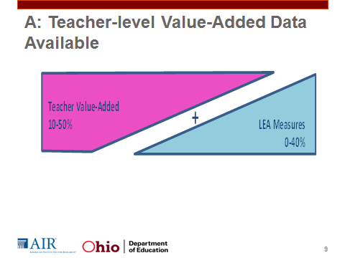
Slide 10  Category B teachers are those teachers with data as given from assessments on the ODE-approved vendor assessment list. You may be using wonderful vendor assessments, but only those approved are considered Category B. If you have Category B assessments given in the manner that the vendor states will provide a student growth measure, then you must use that data as part of the evaluation.  The local board of education will need to determine the percentage of the value added to be used within the evaluation system. The local board of education will make a decision on this for all Category B teachers. This default percentage for the district will be consistent for all Category B teachers. There may be circumstances where this percentage varies; if it does, it should be for valid reasons.  Teachers who fall into Category B typically do not have value-added scores, but do have an approved vendor assessment associated with their classes that can be used to measure student growth. | 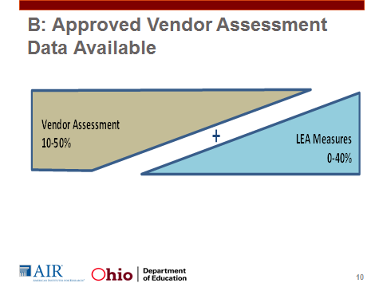
Slide 11  All other teachers will be Category C, those teachers in nontested grades and subjects without comparable vendor assessments or value-added data. These teachers and teachers from Category A or B who use local measures will use the SLO process. | 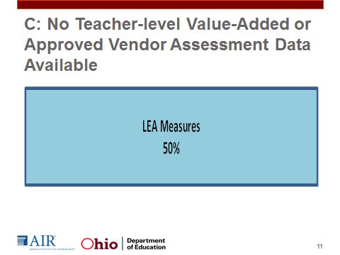
Slide 13  This slide represents a sample district plan for combining multiple measures of student growth. We see that the district has decided that multiple student growth measures will be used in all teacher evaluations. In this example, Category A teachers will have value-added and SLOs as their measures of student growth. The value-added is weighted at 40 percent and the other 10 percent will be based upon SLOs. In this example, Category B teachers will have vendor assessments, SLOs, and shared attribution included in their evaluation, with vendor assessments holding 30 percent weight. Finally, Category C teachers will have evaluations comprised of 40 percent SLOs and 10 percent shared attribution. | 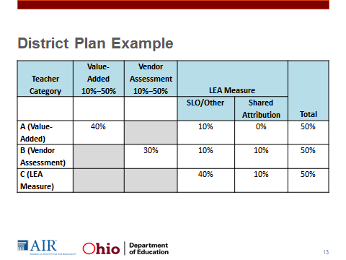
Slide 14  SLOs are goals created by teachers or teacher teams that are designed to demonstrate impact on student learning within a given interval of instruction.  The interval of instruction should generally be the length of the course. That might be a semester or a whole academic year, but the idea is that the goal is capturing the main skills or concepts meant to be taught in this course and whether the teacher has been able to facilitate students in gaining those skills or content knowledge during this time. In order to demonstrate if this has occurred, the goal needs to be measurable. We have to be able to reliably demonstrate through some form of assessments if students have gained the expected skills or knowledge. When we say long term, what we mean is an expected year’s or semester’s growth, as demonstrated on an assessment. | 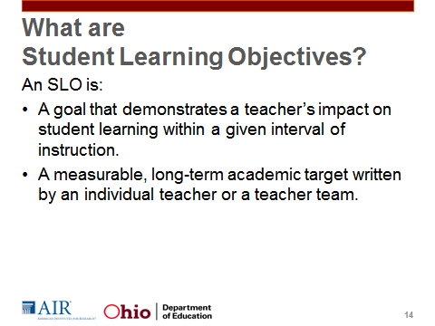
Slide 15  Like all measures, SLOs are imperfect measures of teacher impact on student achievement. However, SLOs offer many benefits.  First, SLOs reinforce best teaching practices and connect those practices to student learning. The SLO process encourages data-driven, long-term planning and goal setting, use of formative assessments to assess progress towards the goal and inform adjustments in practice, and use of summative assessments to assess student learning at the end of the course.  Unlike other measures, SLOs can be used in all subjects and content areas. In addition, they are easily adapted when changes in curricula, standards, or assessments occur.  SLOs also encourage collaboration. Teachers may create a team SLO where they share a goal amongst them. In addition, the SLO process offers multiple opportunities for collaboration: in the analysis of baseline data, in reviewing content standards, in setting growth targets and in selecting appropriate assessments. In fact, a recent evaluation of implementation of SLOs in Indiana found that teachers who had sufficient time to collaborate on the SLO process were significantly more likely to be satisfied with the evaluation system, to agree that the time spent implementing the system was well-spent, to agree that the system is good for student learning, and agree that the evaluation system encouraged data-driven instruction in their school.”  Finally, SLOs provide teachers the opportunity to take ownership of how they are evaluated by selecting the standards and setting the targets against which they will be evaluated. | 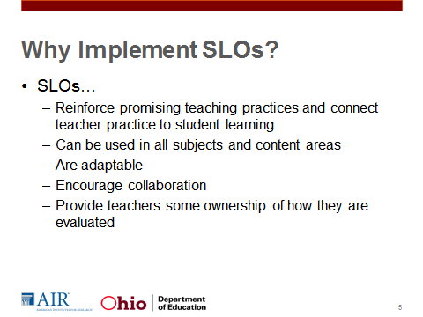
Slide 16  This slide details the overall SLO evaluation cycle.”  During the SLO evaluation cycle, teachers are constantly implementing instruction, evaluating its effectiveness, and adjusting their practice to ensure that students are demonstrating sufficient growth in knowledge and skills. In addition, multiple interactions between the teacher and the evaluator, both to ensure that teachers are on track for completing the process and to provide the teacher with support to ensure that she or he feels she has the tools and knowledge necessary to impact student growth.” | 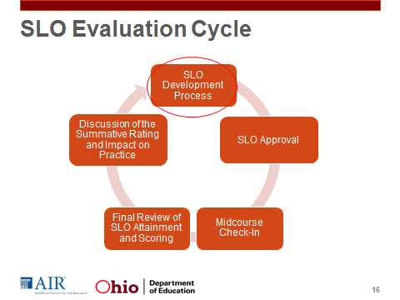
Slide 17  The SLO development process promotes the elements used by a reflective teacher: identifying student needs, setting goals for students, employing specific strategies that target student needs, assessing student progress, and examining outcomes data for next steps. When incorporated into an evaluation system, the process is comprised of these general steps.  This process may seem overwhelming at first glance. However, no teacher needs to go through this process alone. It is strongly encouraged that teachers meet together, either in a Professional Learning Community (PLC), grade-level team, or content-area team to review baseline data, identify the interval of instruction, and identify content. It is strongly encouraged that teachers using the same subjects use the same assessments when they are appropriate and in no case should a single teacher create an assessment. ODE encourages teachers to collaborate throughout the SLO development process. | 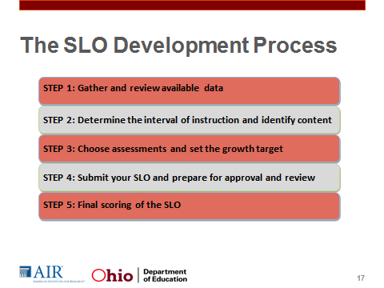
Slide 19  The SLO checklist (Handout 1.3), compiles all of these essential criteria for each component in the SLO template. When writing SLOs, this checklist can be used as a tool to check that all necessary information is included in each component. This document will also be used by evaluators or a local committee when they review the SLO for approval. | 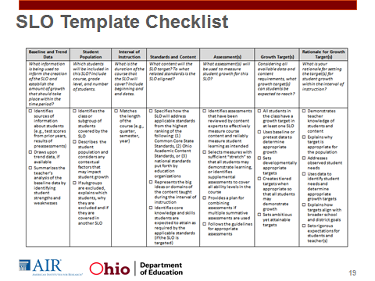
Slide 20  We will review the seven components of an SLO in more detail and think about what needs to be included in each component for the SLO to be high quality. Let’s start by looking at the basic structure of high-quality SLOs. Having this basic structure helps ensure that SLOs are comparable across teachers and accurately demonstrate student learning. In other words, all teachers creating SLOs will have to complete the template and cover all seven of these criteria to have a complete SLO. | 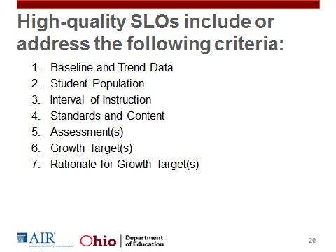
Slide 21  Component 1  - Identifies sources of information: Draws upon baseline data gathered from a district-created pre-assessment.  - Summarizes the teacher’s analysis: The summaries identify strengths (in this case, students struggle less with performances and are strong in ensemble singing and effort) as well as weaknesses (students lack a clear understanding of specific techniques and strategies for improving, are challenged in music theory, interpretation, and pitch).  Component 2  - Identifies the class of students covered by the SLO:  - Describes factors that may impact student growth: | 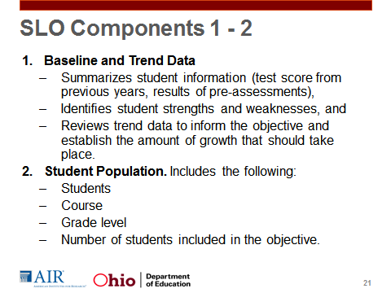
Slide 22  Component 3  Matches the length of the course  This component should detail which content knowledge and skills the teacher expects students to gain, and then to which standards the content knowledge and skills are aligned. All SLOs should be broad enough to represent the most important learning or overarching skills, but narrow enough to be measured.”  Component 4  Specifies how it will address applicable standards: Is aligned to Ohio’s 2012 Revised Music Standards.  Represents the big ideas or domains of the content taught during the interval of instruction: In some cases this will be all content standards, but in most cases the standards should represent the most important learning or overarching skills. | 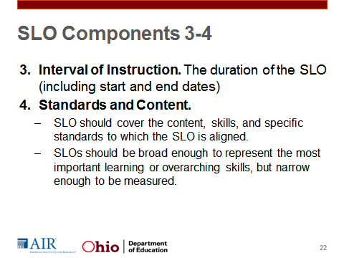
Slide 23  Component 5  Identifies assessments that have been reviewed by content experts: Uses a district-created end-of-course exam.  Follows the guidelines for appropriate assessments: Provides enough detail about the format of the assessment and who was involved in developing it that a reviewer can make a judgment about the appropriateness of the assessment. In this case, the description includes information about the structure and format of the assessment and how the assessment will be scored.  Component 6  Creates tiered targets when appropriate: Uses tiered growth targets where the goals are customized based on the baseline data of students. In this case, the tiered targets are based upon data from the pre-assessment. | 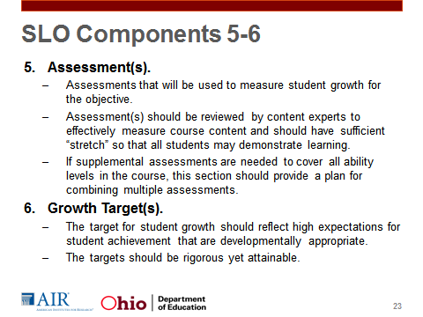
Slide 24  Component 7  Explains why the target is appropriate for the population  Explains how targets align with broader school and district goals  Uses data to identify student needs and determine appropriate targets | 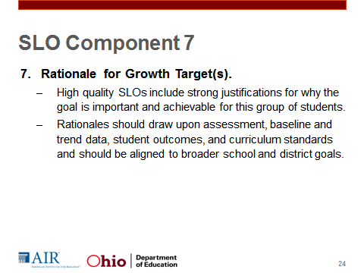
Slide 25  Review The SLO Checklist  Handout 1.3 | 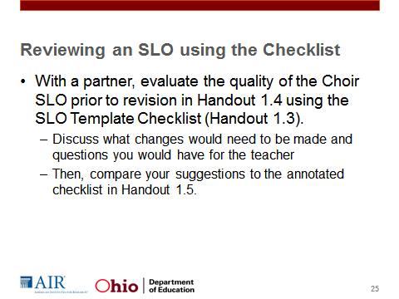
Slide 26  For the approval status, the evaluator should be prepared to engage in a meaningful discussion with teachers on their SLO if they have questions about the content or growth target.  If revisions are necessary, the teacher must revise and resubmit the SLO for review. Handout 1.6 provides a sample form for evaluators to use in communicating the review results. | 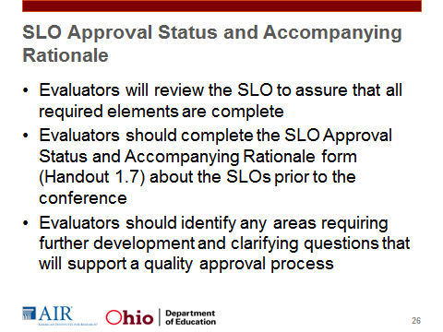
Slide 28  Beginning in 2013–14, the SLO implementation cycle should look more like what you see on this slide. | 